DATA STRUCTURES - FIRST PRACTICE
ALEJANDRO SANTORUM & DAVID CABORNERO

Instructions to create our database. The approach we´ve followed is shown below in next pages.
CREATE TABLE Books(
ISBN int PRIMARY KEY,
Book_id int NOT NULL,
Title varchar(64) NOT NULL,
Formar varchar(32) NOT NULL,
Lang varchar(32) NOT NULL,
Publishing_house varchar(32) NOT NULL,
Price float NOT NULL,
Book_edition int NOT NULL,
CHECK(Price >= 0)
);

CREATE TABLE Authors(
Author_id int PRIMARY KEY,
Name varchar(64)
);

CREATE TABLE Written(
Book_id int REFERENCES Books(Book_id),
Author_id int REFERENCES Authors(Author_id),
PRIMARY KEY(Book_id, Author_id)
);

CREATE TABLE Users(
User_id int PRIMARY KEY,
Name varchar(64) NOT NULL,
Type int NOT NULL,
Spent float NOT NULL,
Credit_card int NOT NULL UNIQUE,
CHECK(Type <2 AND Type >0)
);

CREATE TABLE Discounts(
Discount_id int PRIMARY KEY,
ISBN int REFERENCES Books(ISBN),
Initial_date date NOT NULL,
Final_date date NOT NULL,
Coef int NOT NULL,
CHECK(Coef > 0)
);

CREATE TABLE Sales(
Sale_id int PRIMARY KEY,
ISBN int REFERENCES Books(ISBN),
User_id int REFERENCES Users(User_id),
Purchase_date date NOT NULL,
Discount_id REFERENCES Discounts(Discount_id),
Payment_type varchar(32) NOT NULL,
Final_price float NOT NULL,
CHECK(Final_price >= 0)
);

Design Analysis:

Table BOOKS:
-ISBN: It is the Primary key. It defferentiates all books, in all its editions, languages, authors, etc.
-Book_id: It represents one specific book, even thought its language or number of edition is diferent. It is useful to know what title´s books are the same althought they are in different languages.
-Title: of the book. The title is written in the same language that is wirtten the book.
-Format: specifies if one book is an ebook, a printed book, softcover book, hard-cover book, etc.
-Lang: the language in what the book is wirtten.
-Publishing house: name of the publishing house.
-Price: standard price of a book
-Book edition: books can be improved to fix mistakes or to give more information.

Table AUTHORS:
-Author_id: Primary key of the table. It differentiates all authors.
-Name: name of the author.

Table Written:
-Author_id: author that has written the book specified in the field “Book_id”.
-Book_id: book that has been written the author specified in the field “Author_id”.

Table USERS:
-User_id: Primary key of the table. It differentiates all users.
-Name: name of the user.
-Type: One row is type 0 that includes all non-registered users (Name, Spent and Credit_card are NULL). Rest of the rows are type 1, registered users.
-Spent: Total monet spent by one user.
-Credit_card: Credit card of one user.

Table DISCOUNTS:
-Discount_id: Primary key of the table. It differentiates all discounts.
-ISBN: identifier of the book that is on sale.
-Initial_date: beginning of the discount.
-Final_date: deathline of the discount.
-Coef: coefficient of the discount.

Table SALES:
-Sale_id: Primary key of the table. It differentiates all sales.
-ISBN: indentifier of the book sold.
-User_id: user that has bought the book.
-Purchase_date: date of the purchase.
-Discount_id: if the book is on sale, it informs about the discount. If the book is not on sale, this field is NULL.
-Payment_type: by cash or with credit card.
-Final_price: final price of the book with the corresponding discount made.

*Points which have the potential to introduce inconsistencies in the data:
The design report must also include the posible inconsistencies in the structure of the database. In our opinion, the only inconsistence our database can have is that only one discount (discount_id) is made to a single book (ISBN).I If you want to make the same discount to another book you have to have to include another row in the table Discounts with a different Discount_id, the book that you want to offer cheaper, and the same coefficient.

Entity-Relationship Model:

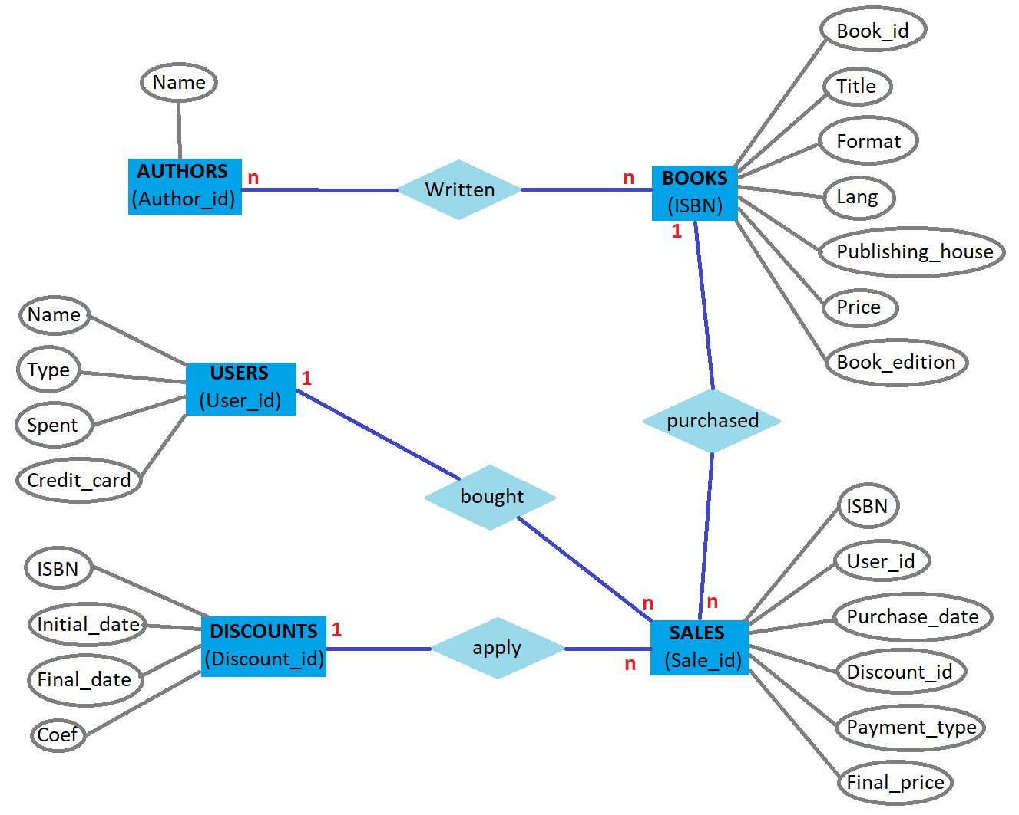

QUERIES

1. Given a title, how many editions does it have? In how many languages?

1.1 SELECT COUNT(Books.Book_id) FROM Books WHERE Books.Book_id IN ( SELECT Books.Book_id FROM Books WHERE Title = '<Title of the book given>');

1.2 SELECT COUNT(DISTINCT Lang) FROM Books WHERE Books.Book_id IN ( SELECT Books.Book_id FROM Books WHERE Title = '<Title of the book given>');

2. How many books of author X were sold?

SELECT COUNT(*) FROM Authors, Written, Books, Sales WHERE Authors.name = 'X' AND Authors.author_id = Written.author_id AND Written.book_id=Books.book_id AND Books.ISBN = Sales.ISBN;

3. How many books of author X were sold at a discount?

SELECT COUNT(*) FROM Authors, Written, Books, Sales WHERE Authors.name = 'X' AND Authors.author_id = Written.author_id AND Written.book_id = Books.book_id AND Books.ISBN = Sales.ISBN AND Discount_id != 'NULL';

4. How much money was earned by selling books of author X?

SELECT SUM(Final_price) FROM Sales, Books, Sales, Authors WHERE Authors.name = 'X' AND Authors.author_id = Written.author_id AND Written.book_id = Books.book_id AND Books.ISBN = Sales.ISBN;

5. How many books were sold to registered users?

SELECT COUNT(*) FROM Sales, Users WHERE Type = 1 AND Users.user_id = Sales.user_id;

6. How many registered users have bought English books?

SELECT COUNT(DISTINCT Users.user_id) FROM Sales, Users, Books WHERE Type = 1 AND Users.user_id = Sales.user_id AND Sales.ISBN = Books.ISBN AND Lang = 'English';

7. How much money was earned by selling books in French?

SELECT SUM(Final_price) FROM Sales, Books WHERE Lang = 'French' AND Books.ISBN = Sales.ISBN;

8. In which days were books of the publisher Adelpi on sale?

SELECT Discounts.ISBN, Initial_date, Final_date FROM Discounts, Books WHERE Discounts.ISBN = Books.ISBN AND Publishing_house = 'Adelpi';

9. Which registered users have never bought paperback books?

(SELECT DISTINCT Users.name FROM Users WHERE Type = 1) EXCEPT (SELECT DISTINCT Users.name FROM Users, Sales, Books WHERE Users.user_id = Sales.user_id AND Sales.ISBN = Books.ISBN AND Type = 1 AND Books.format = 'Pocket edition');

Relational Model:

